How to make a charge-back on your own
An electronic guide
of company Mychargeback

Preface

This guide is intended to help you to perform the refund procedure (charge-back) from scam brokers.

We do gradually depict the procedure, explain how to indicate the reason for protesting
operations and how to submit an application in the bank on your own. This manual contains the compiled and structured experience of Mychargeback in the area of money return. During our work, we have helped people from 6 continents to return money from fraud brokers for a total amount of more than $ 5,000,000.

Every day we receive hundreds of requests for assistance in return of funds. We do carefully process and analyse each one and look for means for reimbursement. This guide is designed to maximize the effectiveness of the self-help when one applies for a charge-back on his own. In our company each file is being processed by a team of qualified professionals. Each of them is responsible for a certain stage of the application and return process. Since the return procedure is not an easy task, we highly recommend very carefully to work over each step and precisely follow the instructions.

Remember that in our case, the application is being processed by a whole team of experts. If you decide to follow the self-service charge-back approach, you need to follow the steps below. The plan is based on our many years professional experience in this area. In addition to information on how to properly initialize the charge-back procedure we have added 3 exclusive bonuses:

BONUS 1: What you didn't know about - how to expose a broker and increase the chances of a successful reimbursement!
BONUS 2: 10 Mychargeback rules on how not to become a victim of a cheater in the future!
BONUS 3: New dodgy tricks of fraud brokers in 2018!

Table of contents

What is a Charge-back?
How to challenge a debit transaction
What you need to know before you challenge a transaction
Preparation of documents
Frequently asked questions
How to prepare an application to the Bank
BONUS 1: What you didn’t know
BONUS 2: 10 secrets on how not to become a victim of brokers deception
BONUS 3: The dodgy tricks of brokers in 2018
About Mychargeback

1. What is a charge-back

The charge-back is the process of challenging bank card transactions made by the holder in a point of sell or using an online store. The procedure is usually initiated by the cardholder. But in some cases the initiator may be the bank itself. The reason for it may be for example an incorrect write-off amount or a system failure.

The procedure is performed as follows: the card holder submits to the bank that has issued the card a respective statement, objecting the transaction. It can be obtained from a representative of the bank or, if the bank does not have a special application form, then you can apply in a free form. The holder must outline the reason why he/she considers the operation being void or fraudulent and attaches all the documents available for this operation (checks, invoices, correspondence, evidence that a service or goods were not provided).

Next, the credit institution conducts an investigation. It submits the cardholder request together with the attached documents, to the MasterCard or Visa payment system, those in
turn inform the acquirer bank (recipient bank) and in case the claim is correct, the erroneously charged amount is returned to the card holder by the point of sell.

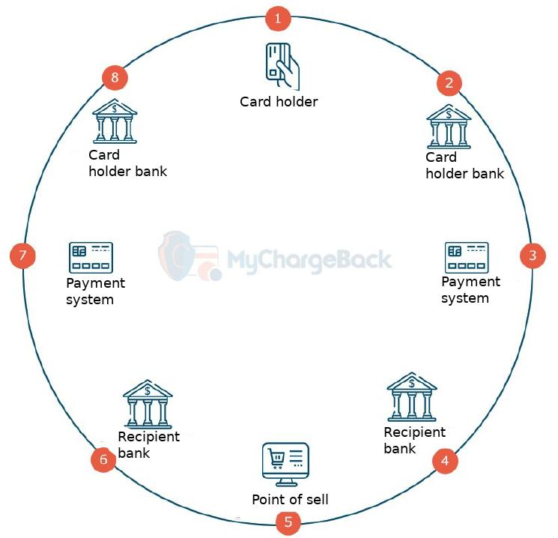

1. Card holder
Transaction Dispute
Provision of all necessary information
2. Card Issuer (Cardholder Bank)
Overview of the possibility to object transactions. If necessary, returns the transaction (charges it back) from the recipient bank account through a payment system such as Visa, MasterCard, etc.
3. Payment system
Reimbursements and responsibility for compliance with technical criteria.
4. Recipient Bank
Reception and resolving of return requests, sending of a notice to the seller (point of sell)
5. Seller
Receiving of a request to return the money to the card holder. If necessary and under certain conditions can challenge the decision of the card issuer and not return the money. However if the conditions were not really met, the seller may have to accept the claim and
return the disputed amount.
6. Recipient bank
The direction of the decision to return the payment to the Payment system.
7. Payment system
Notification of the card issuer regarding the decision.
8. Card Issuer (Card holder Bank)
Customer notification regarding the reimbursement.
9. Card holder
Receives the refunded amount in his/her bank account.

Deadlines for an application for a charge-back

The maximum period indicated by the Regulations of the international payment system, to
challenge a transaction consists of 540 days from the date of the last deposit. We recommend not to delay the challenge, since the preparation of documents for the procedure for the return by the issuing bank and the transfer of the case to arbitration may be delayed. Mychargbeback recommends filing an application no later than 500 days from the date of the transaction.

Important: each payment system (VISA\MasterCard) imposes its own requirements for the timing of charge-back challenging.

In the process of reviewing the claim, a certain period of time is also allocated for each stage:
After the issuing bank receives an application for withdrawal of funds for a charge-back, it is required within 30 - 45 days (for internal and international operations, respectively) to provide the respective data to the payment system;
During the same period, the acquiring bank must provide a feedback regarding the claim;
Upon receipt of the refusal, the issuing bank may send application for a repeated charge-back; When considering a case in front of the arbitration court, the dispute may last several months.

2. How to challenge correctly a write-off operation
Over the past few years, the categories of reasons for which you can initiate a dispute have changed a lot and will continue to develop. To simplify understanding, Visa and MasterCard grouped the reasons into four main categories:

- Permission
- User disputes
- Fraud
- Errors when processing payments

More details about these reasons:
- The seller did not return the goods;
- A double write-off has occurred;
- The operation amount differs from the value of the purchases;
- Incorrect date and time of the operation;
- The signature on the card and in the invoice differ;
- The card holder has not made the respective purchase;
- Money has been withdrawn from the account, but the buyer has not received the goods or the service;
- The buyer is not satisfied with the product or service, for example, the product is different from what was promised earlier by the seller, or the services were not provided to the full extent;
- The customer received the product or service, but used other payment means (cash, another bank card, etc.);
- The seller refused to accept the goods back, etc.

If you have suffered because of a fraud broker or a Forex company, the reason you should
indicate in your claim should refer to the consumer dispute: You have not received the services promised by the broker, as they simply turned out to be nothing more than a video game, a deception.

2.1. What you need to know before you challenge the transaction:
- It is necessary to check all documents (checks, statements)
- Check whether you have placed orders for goods and services by phone, mail or via the Internet, do you have any subscriptions for goods or services;
- Clarify with owners of additional cards if they have performed the respective operation

! IMPORTANT

2.2. Documents preparation
Contact your bank for a special form. Usually it is called “Statement of Disagreement with
a performed operation."

2.3. Frequently asked Questions
How much does the whole refund process take?
In average, 3 - 4 months. We have described above the whole process that fits into this time period. In accordance with the payment systems rules the investigation can take longer depending on the billing systems and the claim reasons. Investigation time is the same for all banks.

Will the funds be written-off if the card was blocked at the moment when the transaction amount was only reserved in the account?
The challenge process can only be initiated after the operation is written off. One needs to declare his/her disagreement if the transaction is not authorized immediately.
What amount you can claim?
You can only claim the amount of the deposit. The bank will not reimburse the interest you have received.

What is the time-frame to apply if you want to challenge an operation?
You can apply for a charge-back no later than 540 days from the date of the transaction.

3. How to draw up an application to the Bank correctly
First of all, you need to clarify with a bank representative or check online if there is a special application form for challenging card transactions (the form is issued in two languages - Russian and English). If such form is not available, you can submit an application in a free form, describing the situation in details and specifying the reason (see Chapter 2) you want to challenge your transactions. Also, you will need to bring evidence, why you think that the respective service was not provided to you to a full extent, why you think that the company is fraudulent, etc.

Your application is intended for the Claims Department, this department reviews all cardholder claims for their transactions, verifies and reveals whether you can claim a refund referring to all the arguments provided. If representatives of this department do not have enough additional documents or evidence, they will inform you about it.

If there is a statement and an evidence, the Claims Department initiates a dispute against the seller who did not provide you with the services, as described on his website (for example, instead of a real investment account, gave you a simulated account, simply speaking, a video game).

Important! First of all, to apply you must provide personal data and documents that justify your claim.

Required documents for a Charge-back submission
You must provide copies of documents confirming the identity of the applicant, and a written statement, which contains:

- Card and account details;
- The number and the date of the contested transaction;
- The amount to be returned;
- A description of the problem;
- Contact details.

Also, you need to provide to the bank all documents and evidences that confirm the fact of the fraud. These include:
- A service contract;
- A history of card operations;
- Screenshots and / or printout of evidence that a service was not provided to you (one of the best evidences for a charge-back);
- Incriminating evidence that the broker is a fraud (lack of regulation, registration in offshore zones, etc.);
- Screenshots and / or printout of electronic or SMS correspondence with the broker;

It may take from one to two months to review and process a withdrawal.

BONUS: What you didn’t know
How to convince the bank about the obvious fact of fraud or money laundering by a brokerage company. These facts are in your hands. Here is a vivid example, the payment for the services you made online actually was made in favour of another company (usually, these are fake companies that are registered in third world countries and are not governed by any laws and regulations)

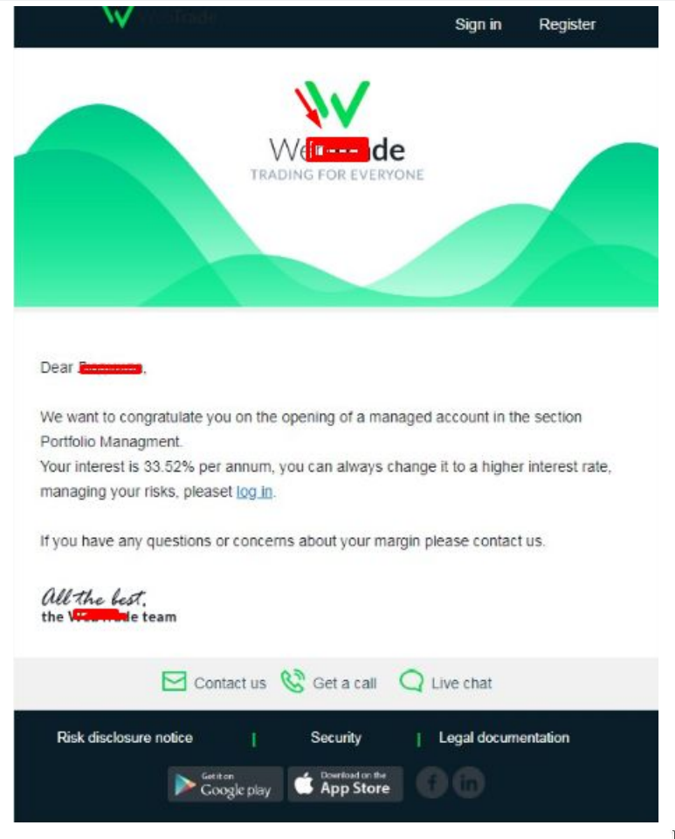

BONUS: What you didn’t know
Account statement.

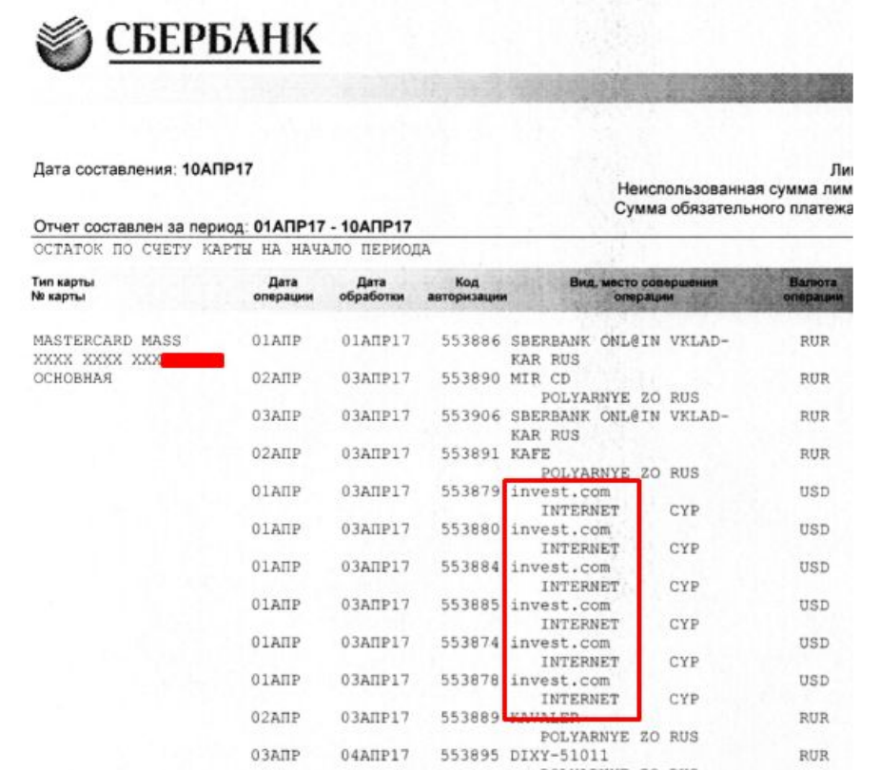
BONUS: What you didn’t know
Another example of a fraud that will favorably affect the decision-making regarding a charge-back by a bank is a deliberately false information from a manager or analyst. In this example, the fraudster broker contacted the investor and put pressure on the adoption of a deliberately false decision:

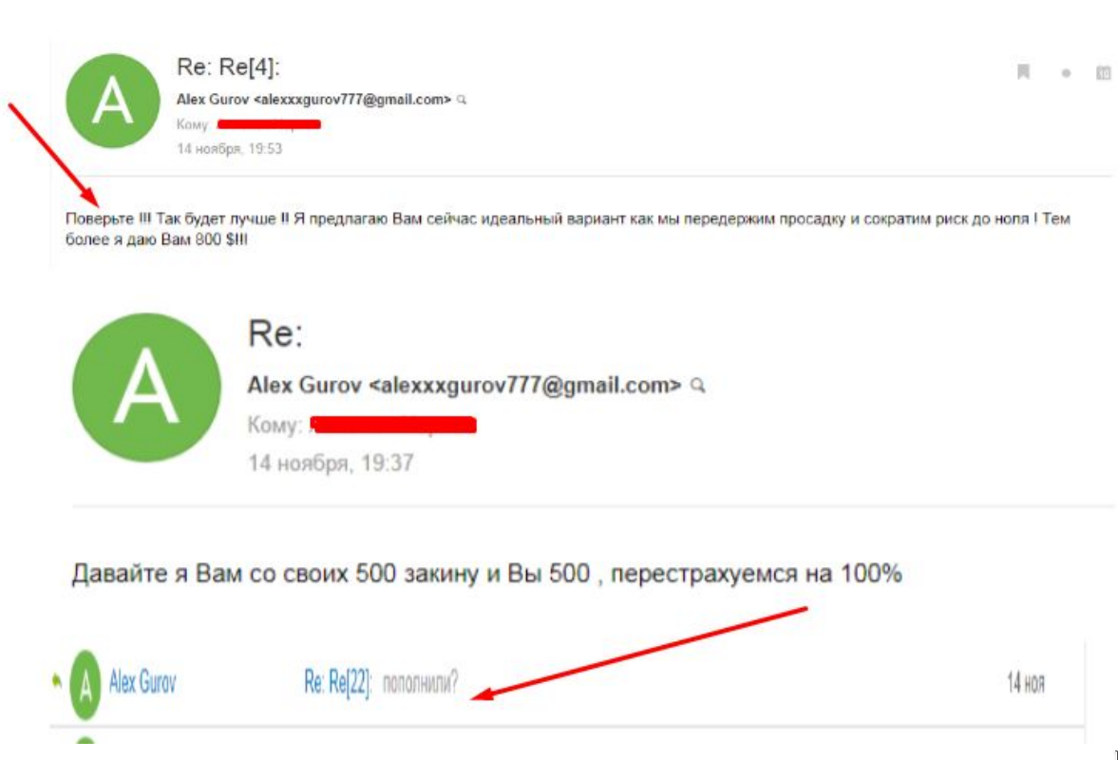

BONUS: What you didn’t know
Another example of a fraud that will favorably affect the decision-making regarding a charge-back by a bank is a deliberately false information from a manager or analyst. In this example, the fraudster broker contacted the investor and put pressure on the adoption of a deliberately false decision:

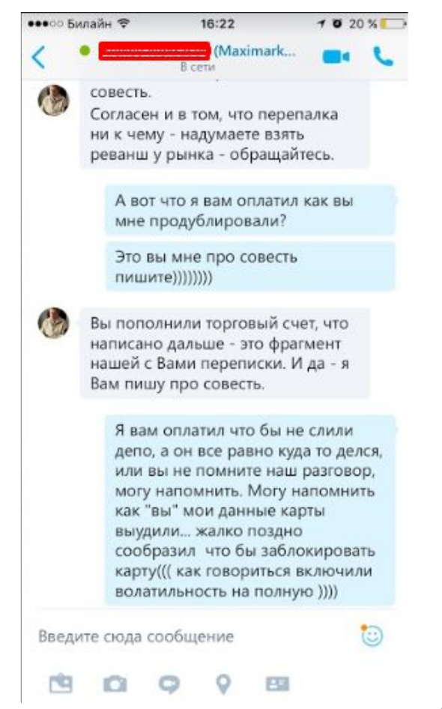

BONUS: What you didn’t know
An example of a company with a head-quarter in an offshore zone

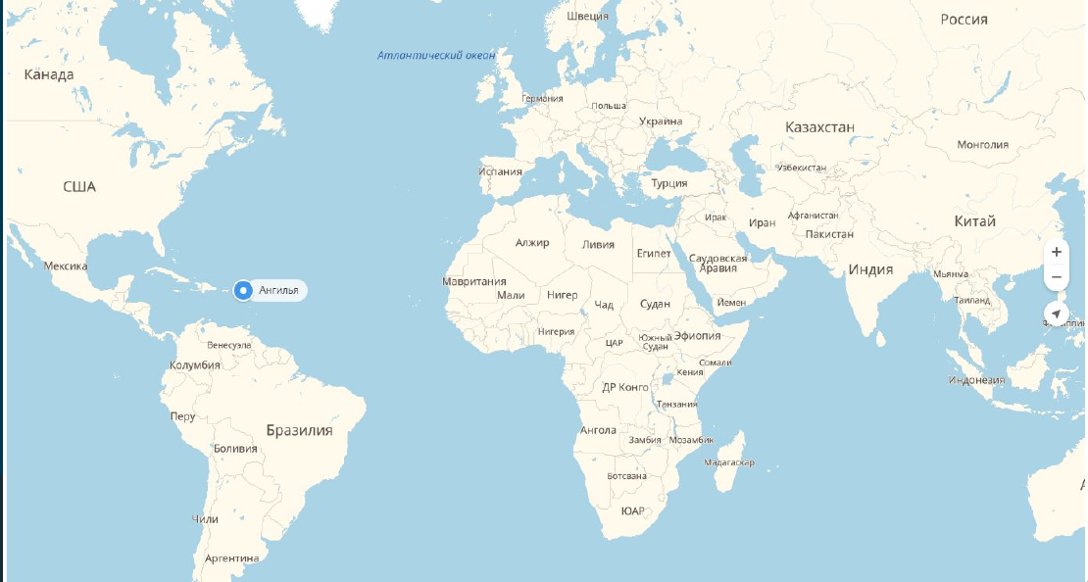

BONUS 2: 10 secrets on how not to become a victim of brokers deception

The number of Forex and binary options platforms is growing every day, promising more and more lucrative offers for gullible traders. During their work, Mychargeback experts encountered various kinds of deception of trustful investors. Each time, fraudsters brokers come up with new ways of cheating and making money on unsuspecting traders.
The company's specialists analyzed a variety of cases and brought out the TOP recommendations that will help you to avoid becoming a victim of a crook and to protect yourself and your money. Very often, at the first contact, fraudster brokers promise that the developed strategy can minimize your risks by up to 100%.
The reason that Forex trading is so successful actually is based on the fact that the risk of losing a deposit is too great. Forex trading is extremely unstable; without proper cash management, an investor can lose most, if not all of his capital, in a few days. Therefore, if the broker promises you to make money without any risk, there is reason to believe that he is a fraudster.

Promises of huge profits
Beware of firms that guarantee huge profits from Forex trading. The so-called “guarantees” of break-even are just tricks to encourage you to make a large deposit. The main task of the fraudster is to make you believe that your money is safe and that nothing threatens it. Such promises are just lies, as even the best professional traders cannot guarantee a profit on any particular day. The Forex market, like most financial markets, is very unpredictable. Therefore, you should be suspicious of such statements and those who make them.

Job announcements
Be very careful of ads for work in brokerage companies and free training. Often, fraudsters specially recruit groups of people to create the illusion that it is very simple and easy to make money on Forex. After that, fraudsters can promise big bonuses if those who have been trained bring new investors to them. By the way, most of the time fraudsters recruit large groups for training, but almost always do not hire. After that, users often decide to try their skills with real money, thus falling for the dirty trick of the deceiver.

Video game
Very often fraudsters use fake platforms that only imitate trade. Do not pay attention to the brightness and the external component of the site, since even the most modern site can be fraudulent. In this case, the resource may not comply with the mandatory rules and procedures of this exchange trading. The resource may not be connected to a real exchange, and all fluctuations in the course and quotes are nothing more than a video game. Fraudsters often use this technique to create the illusion to the users that everything is real. We strongly advise to periodically compare broker resource quotes with indicators of trusted exchanges.

Be suspicious of success on demo accounts
The standard scheme for attracting investors in the field of Forex and binary options is a demo account with a virtual free deposit. It is no secret that test accesses were created specifically for the investor to try his skills in this area, before investing real money. We advise you to be suspicious of situations where you are achieving quick success and have virtually no losses.

As mentioned earlier, a common way to cheat on Forex and binary options is to create a virtual account that is not tied to real price index quotes (like video games), meaning there is no real trading. Very often fraudsters deliberately create the illusion of winning for novices in order to stimulate their excitement to win real money. After a joyful investor achieves first success on a demo account, enterprising scammers contact him, pretending to be analysts and strongly push their victims to deposit real money, explaining that trading on a demo account is no different from a real exchange. And since it turned out to be so easy to succeed on a demo account, you can easily earn real money by replenishing your deposit.

Check broker regulation
Do you know how many regulated brokers provide their services on the territory of the Russian Federation and the former Soviet Union? No more than 10!
Just think, less than 10 brokers have a legal regulation, which will give you at least some guarantee that you can claim a refund in case of a fraud! And now, remember how many broker companies have you heard? 20? 50? 100? 200?

About 95% of all Forex and binary options companies do not have regulations and most of them are registered in offshore zones, such as: Seychelles, St. Vincent and the Grenadines, etc. Such countries do not provide an exchange of tax information and companies are not regulated on the territory of Russian Federation. Therefore, making complaints to law enforcement agencies or to lawyers will bring absolutely no results.

Continue to study broker regulation: check it on the NFA and КРОУФР (CRRPFM Commission for the regulation of relations of participants in financial markets) lists.
Before you transfer your money to a Forex company, verify whether the company you are dealing with is registered with the Derivatives Exchange Commission or the National Futures Association. This organization is a futures association founded in the United States in 1982, as it was necessary to reduce the area of influence of the Commodity and Futures Regulation Commission (CFTC). Today, the reputation of NFA has grown so much that it is considered being one of the most important regulatory structures in the world. Obtaining an NFA license is a guarantee of broker reliability.

Due to this, many financial companies are trying to acquire a NFA license. In Russia and the CIS however not many companies are registered with NFA, so when choosing a broker you should be especially vigilant and check its presence in NFA. The National Futures Association is registered in America. And as you know, the USA has the most stringent regulations and laws, therefore, the activities of companies registered in its territory fall under the most strict conditions.

Important! Mychargeback is managed by Cactil, also registered in the United States, and holds an “A” rating from the Better Business Bureau in New York.

Since 2003, the CRRPFM regulator (Commission on Regulation of Relationships of Participants of Financial Markets) is operating in Russia. Its members are the largest brokers and dealing centers, represented in Russia, who want to ensure the traders rights are protected to the highest extent. CRRPFM is a non-profit organization, it aims to develop the financial services market and regulate the relations among its participants.

"Cold calls" of brokers
To lure customers to themselves, fraudsters often use the method of calling potential customers.
On the Internet there are many opportunities to find information about potential customers. Be careful when leaving information about yourself on the web resources, since your contacts can easily be entered into such kind of database, and then calls will go. Large brokerage companies that have regulations and a large flow of clients will never use such contacts databases, primarily because it affects negatively the company's image.

However, fraudulent and small brokerage companies often practice such a tool to attract customers. The people get called by trained staff who master the basics of psychology and belief, skillfully luring trustful potential traders to them. Remember, large companies do not use the “cold call” technique. Therefore, having received such a call and a lot of promises about quick earnings, it is more likely that you are contacted by a real scammer.

Be careful with document verification
Of course, verification is required when working with brokers. Especially when you are going to withdraw funds. To verify the documents most often asked are:
● Copy of ID card / passport
● Confirmation of registration address (usually utilities payment check)
● Scan of your debit or credit card
● Deposit replenishment declaration with your signature

We strongly recommend to pay attention to all above items before sending documents to the broker for verification.

In this case, the broker is a fraudster, he will need your documents in order to justify and legalise his income and unfortunately also to have the option to cancel an eventual charge-back procedure more complicated. It happens when you intitiate the refund procedure and submit the application to the issuing bank.

As a self-protection, the fraudster broker can transfer your documents as an evidence that you voluntarily agreed to work on his platform. Thus, the fraudster makes a refusal and sends it to your bank, supporting his arguments with your documents and a trade report with your activities. In this case, the charge-back procedure is more difficult.

<има повтаряща се страница в оригинала>
BONUS 3: New dodgy tricks of fraud brokers in 2018!

Be careful with document verification
You must understand that fraud brokers are aware of the Charge-back procedure and are well aware of your ability to apply for a refund. As mentioned earlier, when initiating the charge-back procedure, you follow the security policy of payment systems and rely on their security policies.

By starting a cooperation with a broker, we recommend depositing funds through the VISA payment system. As of today, you have the most realistic changes to return your funds via a charge-back procedure if using this payment system. Sly brokers are well aware of this and often force their customers to use the following systems to replenish the deposit:

● MasterCard and Maestro Cards
● Virtual wallets (Yandex Money, Qiwi, etc.)
● Bank transfers

At a first glance, it may seem that this is done for the convenience of users. In fact, everything is not that simple. In April 2017, MasterCard has made changes to the rules of the MasterCard payment system, prohibiting disputing transactions made in favor of brokerage services. This makes the MasterCard refund procedure virtually impossible today.

Important! Mychargeback has close relations with MasterCard representatives and we are aware of future changes in favor of investors when using this payment system. Contact our managers for more information regarding MasterCard.

The situation with virtual wallets, such as Yandex Money, Qiwi, etc. is very similar. The refund procedure can be initiated, but is much more complicated. Bank transfers also have their own specifics. For bank transfers, it is impossible to initiate the charge-back procedure; therefore, it is necessary to be very careful if you decide to use a bank payment to transfer money to your broker.

Important! Mychargeback offers a unique service of a return of funds from bank transfer payments. Contact our managers for more detailed information on it.

A new scam trend is the collaboration through partnerships with bloggers and forums.
As you know, there is a very well developed affiliate program in the Forex and binary options area. Brokerage companies are ready to pay really big bonuses to those who can bring new clients. Therefore the fraud on affiliate programs becomes more and more popular.

We do not say at all that all blogs, forums and articles about brokers have affiliate agreements and are created only to deceive you! On the contrary, many of them are really unbiased, fair and intend to provide users with a reliable information. We only recommend checking the quality of all reviews on your own: You should be wary of reviews of brokers on the Internet: both positive and negative. Positive feedback on brokers on forums, blogs and other sites may indicate that a partnership agreement has been concluded between the resource and the broker company. For each user registered in the company's broker, the resource receives a certain bonus. Negative reviews can be specifically posted to reduce the credibility of competitors.
Therefore, we recommend checking all the information on your own!
About Mychargeback

The company Mychargeback specializes in the return of funds from scam brokers in the field of unregulated binary options, Forex and crypto-currency. During our work we have accumulated impressive financial and legal experience working with fraudulent broker companies, various banks and helped our clients win the most difficult cases in many countries. We consider individually each situation of our clients.

Mychargeback experts keep a strict confidentiality in their work and do not publish personal information about their clients: names, cases or their accounts. We are one of the world market leaders in returning funds, which proves our efficiency. Mychargeback is owned and operated by the American company Cactil LLC, headquartered in New York, with support offices in Israel, Norway and Russia. Our staff consists of experts from the financial industry with dozens of years of international experience. We offer our clients individual cash back programs that suit their individual needs.

We hold the A rating from the Better Business Bureau in New York. By May 2018, we had successfully returned more than $ 5 million to customers in six continents.

